ECE 445

Senior Design Laboratory

Final Report

**Automatic Humidity Sensing and Water Refilling Cool-Mist Humidifier**

**Team No. 11**

Andrew Sherwin

(zyxie2@illinois.edu)

Jalen Chen

(jalenc3@illinois.edu) Woojin Kim

(wkim51@illinois.edu)

***TA***: Surya Vasanth

***Professor***: Dr. Jonathon Schuh

May 1, 2024

## Abstract

Improper indoor humidity levels are a cause for health issues, such as dry skin or inflamed sinus passages. With the majority of humidifiers on the market being manually controlled, this causes an issue when no operator is present. A room can be under-humidified or over-humidified when there is no one to control the humidity output. As a result, we propose a cost-effective humidifier that will mitigate this problem. Concerned about the health of the operator, a cool-mist humidifier design was chosen. This humidifier communicates via 2.4GHz WIFI with multiple remote humidity sensors before determining the need to turn itself on or off. When the humidifier filter needs more water, the humidifier will activate a water valve that will irrigate the filter to the perfect amount. With all the components combined, this humidifier brings a new perspective to the humidifiers already on the market, guaranteeing the safety and comfort of the user. A truly luxurious experience.

Table of Contents

Abstract ii

1 Introduction iv

1.1 Visual Aid v

1.2 Physical Design vi

1.3 High Level Requirements vii

2 Design viii

2.1 Block Diagrams viii

2.2 Humidifier Subsystem xi

2.2.1 Overview xi

2.2.2 Requirements xiii

2.2.3 Design Decisions xiii

2.3.4 Humidifier Subsystem RV Table xiv

2.3 Humidity Sensor Subsystem xvi

2.3.1 Overview xvi

2.3.2 Requirements xvi

2.3.3 Design Decisions xvii

2.3.4 Humidity Sensor Subsystem RV Table xvii

3 Cost Analysis xviii

3.1 Parts and Materials xviii

3.2 Estimated Hours of Development xviii

3.3 Approximate Total Cost xix

4 Conclusion xx

4.1 Accomplishments and Uncertainties xx

4.2 Future Work xx

5 Appendix xxi

5.1 Appendix A – RV Table Verifications xxi

5.2 Appendix B – Schematics xxvi

5.3 Appendix C – Required Parts and Cost xxxii

5.4 Appendix D – Ethics and Safety xxxiv

5.5 Appendix E - References xxxvi

# 1 Introduction

The United States Environmental Protection Agency (EPA) strongly suggests the regulation of indoor humidity to be between 30%-50% [8] When indoor humidity falls within these ranges, pollutants, such as chemicals, gasses, mold, and other airborne particles, are minimized in the air. This ultimately helps with allergies, respiratory illnesses, and other health issues.

To maximize the health benefits of our product, we decided to implement a cool mist humidifier. Unlike ultrasonic humidifiers and warm mist humidifiers, this product does not disperse bacterial matters, minerals, or cause your nasal passages, as the US Food and Drug Administration (FDA) suggests [25]. To further improve humidifiers on the market, our humidifier features an automatic-on function and an automatic water tank filling function. The solution has three remote humidity sensors. These sensors detect the humidity and communicate the humidity readings with the humidifier. Using the average of these readings, with the temperature accounted for, the humidifier decides whether it is necessary to turn itself on or off. Inside the water tank of the humidifier are two water sensors. One sensor detects whether more water is needed, while the other sensor detects when to stop automatically adding water. Furthermore, a webpage for the humidifier allows the user to read the current humidity and temperature and has options to turn the humidifier and water valve on manually. With all these improvements, we push out a revolutionary humidifier system onto the market that has a high level of autonomy, providing a luxurious product to the end-user.

## 1.1 Visual Aid

###### Figure 1: Consumer Visual Aid [26]

The visual aid (*Figure 1:* Consumer Visual Aid [26]) supports better understanding of how our product gives a solution to the suggested problem. Water supplied through water input to the tank will be brought to the filter located under the fan, then the fan will help to blow water out to the air. After the humidifier receives humidity data from the sensors, it will calculate then decide whether to turn the fan on/off.

## 1.2 Physical Design

###### Figure 2 – Component Visual Aid [27]

The physical design offers detailed information about inner components of the product. Two water-level sensors will be located vertically on the water tank to send fill/stop-fill signals to the ESP32 on the humidifier to open/close the DC water valve. It also shows the water filter that must be changed routinely to prevent potential hygiene risks. After reading humidity data, the humidity sensor will send its ESP32, then it will transmit the data to the humidifier ESP32 through 2.4GHz Wi-Fi.

## 1.3 High Level Requirements

Our project would need to achieve a multitude of high-level goals to be sufficiently complete. Some goals would include:

1.    The ESP32 can read data from the humidity sensor using the ESP32 microcontroller communication through the three different sensors placed around the room, communicating all with ESPs via 2.4 GHz Wi-Fi with continuous readings. This will allow us to use average humidity to determine a good range for on/off functionality.

2.    The filter irrigation system refills the water tank with water depending on signals from two water level sensors at top and bottom of the tank. The ESP32 will activate the 12V DC water valve, creating a flow of water which will turn off when the top sensor detects water. The measured max capacity of the water tank, according to manufacturer specifications, should be 4.16 liters every 24 hours and the filter should absorb around 150 milliliters ± 5 milliliters.

3.    The humidifier should be operating between 35% and 50% humidity. If the value is beyond 50, the humidifier turns off, and if below 35, it turns on. With remote communication between the humidity sensor’s ESP32 microcontroller and the humidifier’s ESP32 microcontroller, there is a theoretical estimation of 44ns response time to the activation and the deactivation of the humidifier’s fans, when algorithm and code run-times are not considered. Furthermore, high voltage parts of the PCB will not affect the ESP32 and other low voltage parts.

# 2 Design

## 2.1 Block Diagrams

###### A screenshot of a computer Description automatically generatedFigure 3 – Overall Block Diagram [28]

###### A screenshot of a phone Description automatically generatedA diagram of a system Description automatically generatedFigure 4 – Humidifier Subsystem Block Diagram (Close-up) [16]

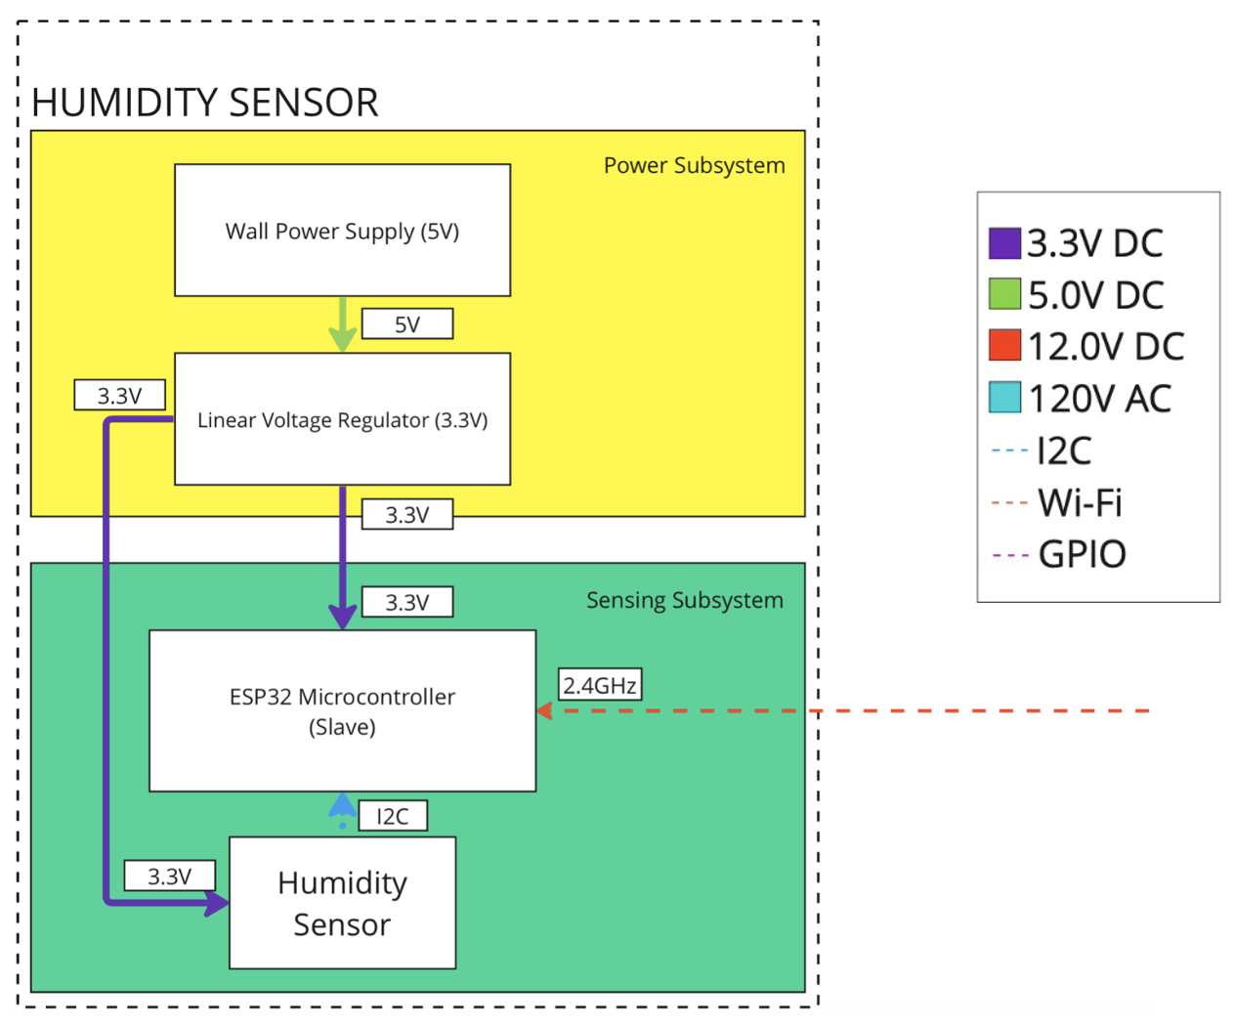

###### Figure 5 – Humidity Sensor Subsystem Block Diagram (Close-up) [15]

Our block diagram Figure 3 – Overall Block Diagram in is divided into two main parts, the Humidity Sensor subsystem and Humidifier subsystem. Within the humidifier subsystem, *figure 4,* consists of the MCU, water sensor, fan, and water valve subsystems. The external power supply subsystem acts to supply power to our entire humidifier subsystem. The external power supply subsystem will have a plug from the wall/mains voltage, which is a 120V AC source. These will directly tie into two different switching power transformer supplies, which will regulate the values down to 12V DC for one of them and 5V DC for the other one. The reason we need these values is to create a baseline to power the rest of our system, as those are values that we need for specific subsystems that we will be using. So, for the 120V AC, this will be going to an electrical relay connected to the fan for our fan subsystem, which will be used for turning on and off our humidifier fan based off a GPIO signal from our MCU. Then the 12V DC from the transformer will be used for the other relay for the water valve subsystem that will be used to control the DC water valve. This relay would operate like a fan relay, using a signal to switch on and off the fan, based on the data we received from the water sensor subsystem. The 5V supply will be used for the water level and MCU subsystem. The water sensor system will then have an additional linear voltage regulator to ensure that the value is 5V from the supply, and then use that as our input to the water level sensors, as they needed 5V to be usable and to send a signal that water was being sensed when in contact with them. Then as for the MCU system, this system will be able to control every other subsystem that we have. The 5V will be dropped to 3.3V, which is the ESP32 MCU voltage needed for operation, and this voltage to the MCU will be used to control various parts of our design. So, our microcontroller will use GPIO signals to communicate between both our relays and the water level sensors, while using the 2.4 GHz Wi-Fi to communicate with the humidity sensor subsystem.

The humidity sensor subsystem, *Figure 5 – Humidity Sensor Subsystem Block Diagram (Close-up) ,* is the 2nd subsystem that we will be using. We will have 3 of these, and the power supply will be a wall plug connected to our PCB with a barrel jack connector. This wall plug will convert the 120V AC from the wall to 5V DC to this subsystem, which will then be regulated to 3.3V from a linear regulator. This will allow us to have the same function to provide our MCU with the necessary 3.3V, and then this communicated with the humidifier subsystem MCU as explained above with the 2.4 GHz Wi-Fi. The ESP32 MCU and the SHT45 humidity sensor are both included in the sensor subsystem as seen above in *Figure 5 – Humidity Sensor Subsystem Block Diagram (Close-up)* . The SHT45 humidity sensor in this system is used to calculate the humidity and temperature value around the room, sending back data to the MCU via standard-mode (100kHz) I2C.

## 2.2 Humidifier Subsystem

### 2.2.1 Overview

Our humidifier subsystem is responsible for controlling the operation of the humidifier fan and the water valve. It controls the humidifier fan by receiving humidity and temperature data via 2.4GHz Wi-Fi from the sensor subsystem. After receiving this data, it will use the humidity and the temperature, through an algorithm, to control the operation of the humidifier fan. Similarly, the water valve is controlled depending on the signal received from two water level sensors.

Referencing Figure 4 – Humidifier Subsystem Block Diagram (Close-up) , we can see that 120V AC goes into the humidifier subsystem. Going through two switching regulated supplies, it is regulated to 5V DC and 12V DC. This 5V DC is then regulated to 3.3V DC using a linear voltage regulator. The regulated voltage is used to power the ESP32 and two relays. The relays are activated using GPIO signals (3.3V DC) from the ESP32. When the GPIO signal is high, the relay provides 120V AC to the humidifier and 12V DC, from the switching regulated supply to the water valve. Finally, the 5V DC is also regulated again with a linear voltage regulator prior to powering the water level sensors. The water level sensors will send a high signal to the ESP32 when no water is detected.

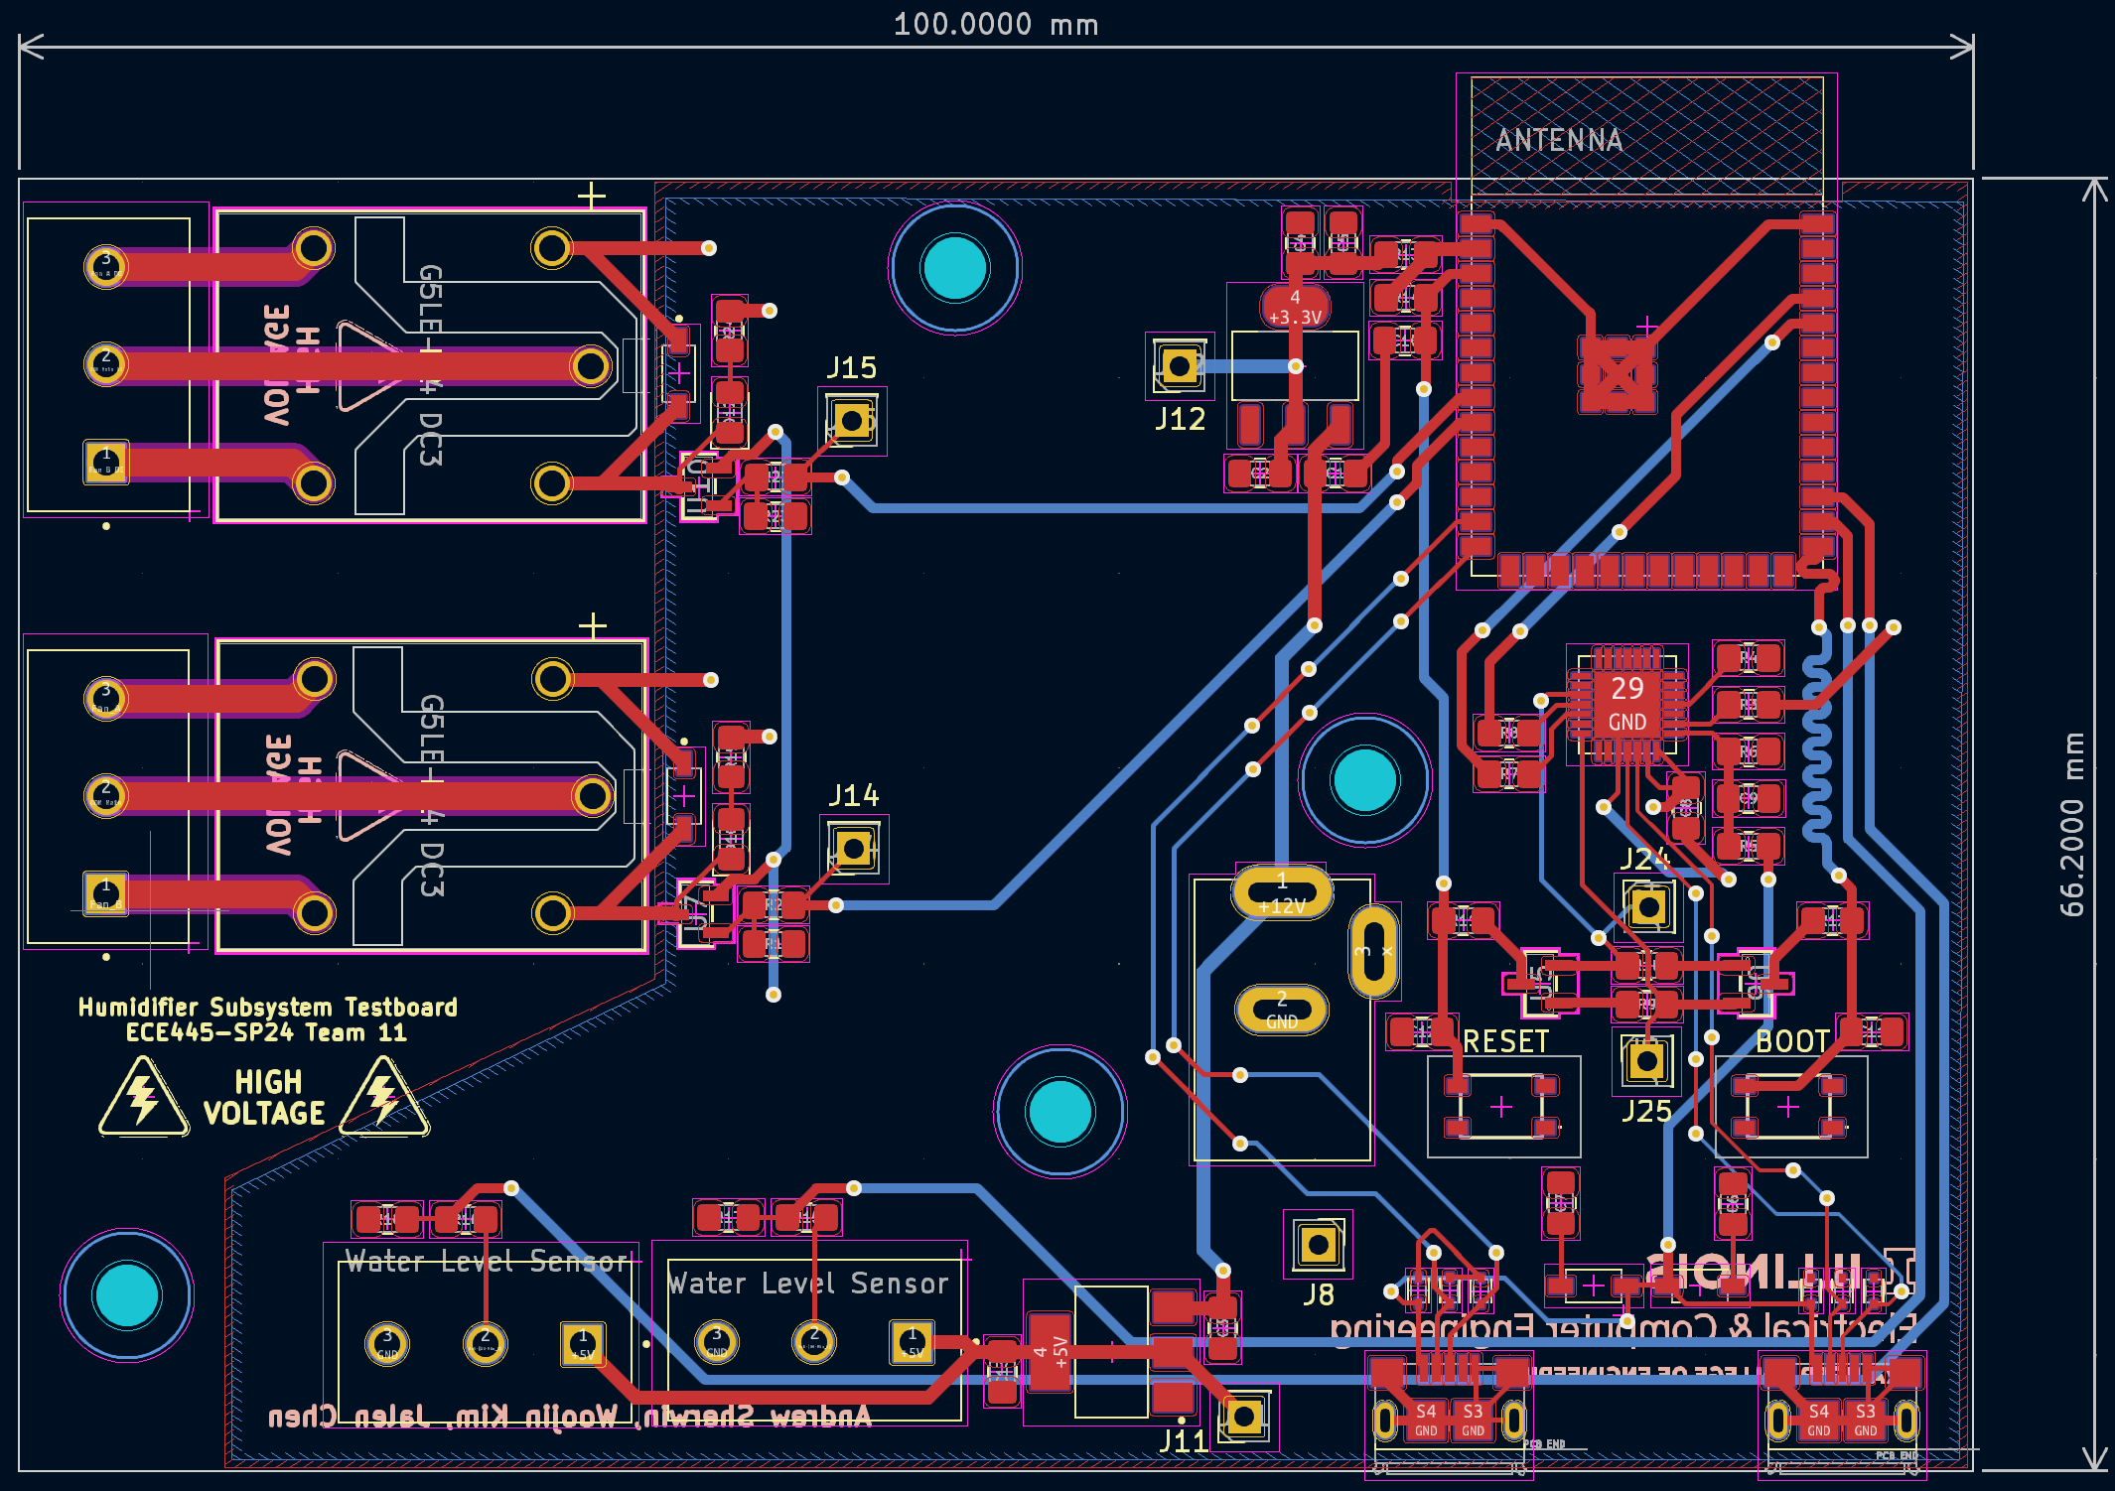

###### Figure 6 – Humidifier Subsystem PCB [29]

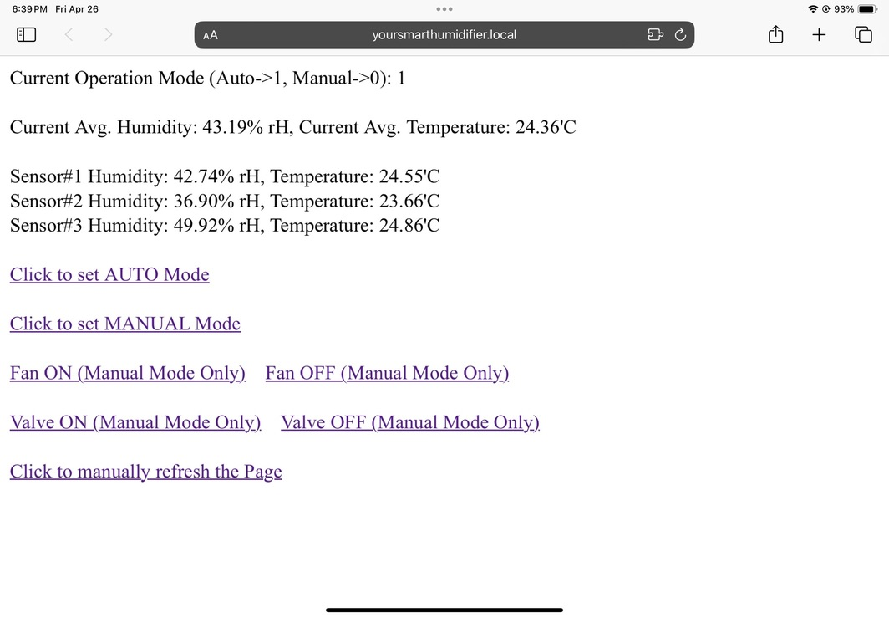

###### Figure 7 – Webserver Webpage [30]

To control the humidifier, the webserver in *figure Figure 7 – Webserver Webpage* was created to display the current averaged humidity and temperature readings. User, once connects to the ESP32 Wi-Fi network, can use the following domain address, yoursmarthumidifier.local to access to the webserver. This design (implemented with mDNS) was chosen since IP address is hard to memorize and can be changed. The webserver also provided a way for the user to utilize a *manual* mode where the humidifier and water valve can be turned on and off manually. For safety purpose, once user comes back from Auto to Manual mode, the fan and water valve will always be in off status. Lastly, to advance our humidity target logic, we put temperature into the algorithm calculation. Since warmer air, compared to colder air, can handle more moisture, the humidifier, if the average temperature is above 22’C (ideal room temperature is 20-22'C), it will target top half range, 42.5-50% Rh, if it’s below 20’C, it will target bottom half range, 35-42.5% Rh and else 35-50% Rh. Furthermore, the web updates every 2 seconds so that there’s no need user to manually update to see the updates.

### 2.2.2 Requirements

1. Powered by a 5V DC source and is regulated to 3.3V through a linear voltage regulator.
2. Communicates with ESP32 in sensor subsystem to receive humidity and temperature data.
3. ESP32 controls activation of water valve and humidifier fan through relays
4. ESP32 determines water level via two water level sensors

### 2.2.3 Design Decisions

In our original proposal, we planned to use a 12V input into the humidifier subsystem. This will negate the need for multiple transformers and multiple voltages. However, 12V regulated to 3.3V using a linear voltage regulator is highly inefficient. The inefficiencies are dissipated as heat. As a result, we opted to use a 5V input to the PCB instead. In the graph below, we can see the voltage from the 3.3V regulator and the temperature is stable over 1-hour.

To have high voltage components on the board, the design decisions of isolation, clearance, and creepage had to be used. This can be seen in *Figure 6 – Humidifier Subsystem PCB ,* where the humidifier subsystem PCB is shown. To isolate our high voltages from our low voltages, we did not have a copper pour surrounding the 120V AC components. To increase the clearance and prevent creepage, cutouts were made on the PCB to physically distance the high voltage from the low voltage. To prevent noise, we added optocouplers to isolate the noise of the AC voltage.

### 2.3.4 Humidifier Subsystem RV Table

|  |  |
| --- | --- |
| Requirements | Verification |
| * Provide 3.3V +/- 0.5% from an input voltage of 5V +/- 0.1% DC source * Thermal stability maintains below 120’C | * Use multimeter to test and take average voltage output over 1-hour to test stability (*Figure - A-1* , *Figure - A-2* ) * Monitor heat dissipation with thermal laser gun over an average of 1-hour use time, expected +/- 5’C under load (*Figure - A-3* ) |
| * ESP32 communication with remote sensor ESP32 utilizing 2.4GHz Wi-Fi | * Verify functionality of ESP32 Wi-Fi component by creating an access point, and accessing access point to remotely turn on LED lights (*Figure - A-4* ) * Verify communication between two ESP32 boards by sending command to turn on LED light from one ESP32 board (*Figure - A-4* ) * Verify thermal performance of ESP32 chip during operation by probing with a laser thermal gun (*Figure - A-1* ) |
| * ESP32 control of activation and deactivation of water valve * ESP32 control of activation and deactivation of fan | * Verify functionality of ESP32 communication with DC relay by sending activation signal to water valve/fan DC relay controller, and when signal is received, DC relay controllers output a lit LED light (*Figure - A-5* )   Probe the output voltage of the DC relay controllers to make sure it is 12V +/- 0.5%  (   * *Figure - A-6* ) |
| * ESP32 detects signals from two water-level sensors | * Contact/No Contact water to the water-level sensors and check through Arduino IDE to see if ESP32 receives contact/no contact signal from the two water-level sensors *(Figure - A-7 )* * Water level sensor low signal when in contact with water, and high signal when not in contact with water (*Figure - A-8* ) |

The data we have in *Figure - A-2 and Figure - A-3* show the temperature and voltage graph over time that was measured in our verification tests. As listed, the voltage was measured through the multimeter over an entire hour, as seen in the graph in *Figure - A-2 ,* taking a data point every minute. The average voltage is relatively stable with no major fluctuations and proves that our input source is stable to the condition we want. The temperature from the thermal laser gun is the same procedure, and as you can see, the temperature starts off at room temperature and then slowly builds up as the system consumes power and expels energy in the form of heat. Then it stabilizes after a while indicating that temperature is within operating range for our components. So the first 2 requirements have been fulfilled. Then the next requirement is that the two MCUs can communicate correctly with 2.4 GHz Wi-Fi. So, we first tested the Wi-Fi capability independently by itself by creating an access point. We would be able to see this access point by connecting it to with our phone. Then we tested the communication between two boards with this now-working Wi-Fi. We created a light to blink on one board when receiving a signal from a separate MCU, which worked both ways, so this proves dual-mode communication of reading and writing and also the Wi-Fi running at full load.Then wetested the thermal performance of the ESP32 chip with the same thermal laser procedure, concluding that the temperature values were within acceptable ranges.

For our next requirement, we needed to verify both the relays to make sure the water valve and fan can both be controlled through GPIO signals from our MCU. These relays would act to turn on and off by sending an electronic signal. The way we verified this step by step was to continuity test the relay to make sure the switching properly works, and then sending signals to the specific relay to make sure that the LED light signal turns on as a test when in normally open and normally closed configurations. Then we probed voltage to make sure the proper amount is going through, anticipating the relay electromagnetic coil to work as well. Finally, the last requirement was to test the water level sensors and see a signal received from them in contact with water or not. We set the signals listed as such in the RV table below.

## 2.3 Humidity Sensor Subsystem

### 2.3.1 Overview

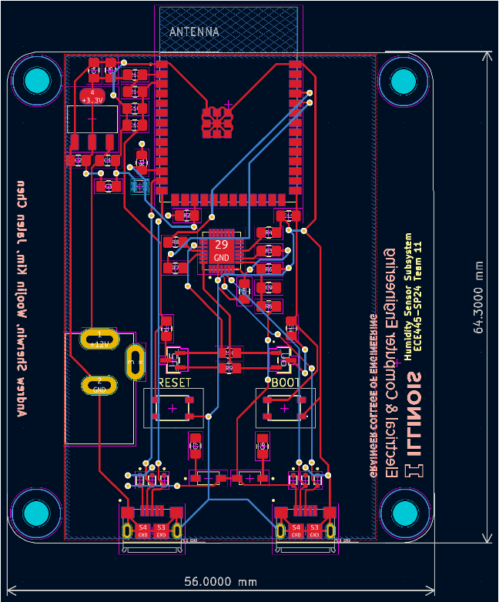Each of the three humidity sensor subsystems acquires temperature and relative humidity data from its own SHT45 sensor mounted back of the PCB through I2C, then sends the message structure including the data to the humidity subsystem’s ESP32 over 2.4GHz Wi-Fi. 5V DC input is regulated by linear voltage regulator, then provided to both ESP32 and SHT45.

###### Figure 8 – Sensor Subsystem PCB [31]

### 2.3.2 Requirements

The sensor system satisfies the following requirements:

1. Voltage needs to be stable, 5V +/- 0.1% DC source voltage and 3.3V +/- 0.5% input
2. System temperature needs to be maintained below 120’C
3. ESP32 needs to receive temperature and humidity data at least once a minute
4. Sensor needs to accurately measure humidity data (at least range in between 25% - 55%  Relative-Humidity)

### 2.3.3 Design Decisions

At the back of our sensor subsystem enclosure, a hole with a rubber grommet is designed to isolate the SHT45 sensor. This will prevent humidity inside the box from affecting the SHT45 sensor. Furthermore, the SHT45 sensor is on the back of the PCB, as seen in *Figure 8 – Sensor* Subsystem *PCB* . This design decision was made so that temperature from the ESP32 and the linear voltage regulators will have less effects on the SHT45 humidity and temperature sensor.

If completed again, the PCB design will not have the programming components for the ESP32. The ESP32 will be programmed on a separate PCB and transferred and soldered onto the final sensor subsystem PCB. This will compact the size of the PCB.

### 2.3.4 Humidity Sensor Subsystem RV Table

|  |  |
| --- | --- |
| Requirements | Verification |
| * Provide 3.3V +/- 0.5% from an input voltage of 5V +/- 0.1% DC source * Thermal stability maintains below 120’C | * Use multimeter to test and take average voltage output over 1-hour to test stability  (*Figure - A-9 , Figure - A-10 )* * Monitor heat dissipation with thermal laser gun over an average of 1-hour use time, expected +/- 5’C under load  (*Figure - A-11* ) |
| * ESP32 communication with humidity sensor receiving humidity data at least once in a minute * Humidity sensor measuring humidity data at least between 25% - 55% | * Verify communication between ESP32 and humidity sensor Arduino IDE by checking humidity data ESP32 receives   (*Figure - A-12* ) * Compare the humidity data received by ESP32 to the commercial humidity sensor and check if the humidity is within +/- 3% *(Figure - A-12 )* * Make the air dry/moist to see if the sensor can measure humidity between 25% - 55%  *(Figure - A-12 )* * Exhale on sensor to see humidity levels are raised *(Figure - A-12 )* * Compare humidity reading with reference humidity reader  *(Figure - A-12 )* |

*Figure - A-9*  shows the multimeter and thermal laser gun those used to verify the requirements of the subsystem. In the next figure, *Figure - A-10*  shows the data we have for measured voltage every minute over an hour. Two voltage graphs show that the two voltages are stable within the proposed gap. *Figure - A-11*  shows the data we have for measuring temperature every minute over an hour. It starts with room temperature and converges to the stability point which is under 120'C. These indicate that the first two requirements are verified as we supposed. Next, we verified the steady reading of SHT45 data by checking the Serial Monitor of Arduino IDE (check so that ESP32 can obtain the SHT45 data at least once a minute), this is further verified as the data gets updated every few seconds on the webserver. Lastly, in*Figure - A-12* , it shows the comparison of our sensors data with the commercial humidity sensor and verified that the difference between the average humidity and the commercial humidity data is within a 3% gap. Finally, by blowing to the sensor manually, we also verified the ESP32 reacts to the change in moisture in real-time.

# 3 Cost Analysis

## 3.1 Parts and Materials

For this project, we created 2 different PCB boards to fulfill our 3 humidity sensor subsystems and our central humidifier subsystem. The parts used are provided, with name, part number, amount required per system, and the individual cost added up together. *Figure C-1 - Sensor Subsystem Parts* and *Figure C-2 - Humidifier Subsystem Parts*  is a table of the required parts and materials for just the PCBs. We also purchased additional components, wires, and mechanical tools to help us connect the project together into a design that enables functionality without loose ends, such as connections hanging around. The total cost adds up to around $680.95.

## 3.2 Estimated Hours of Development

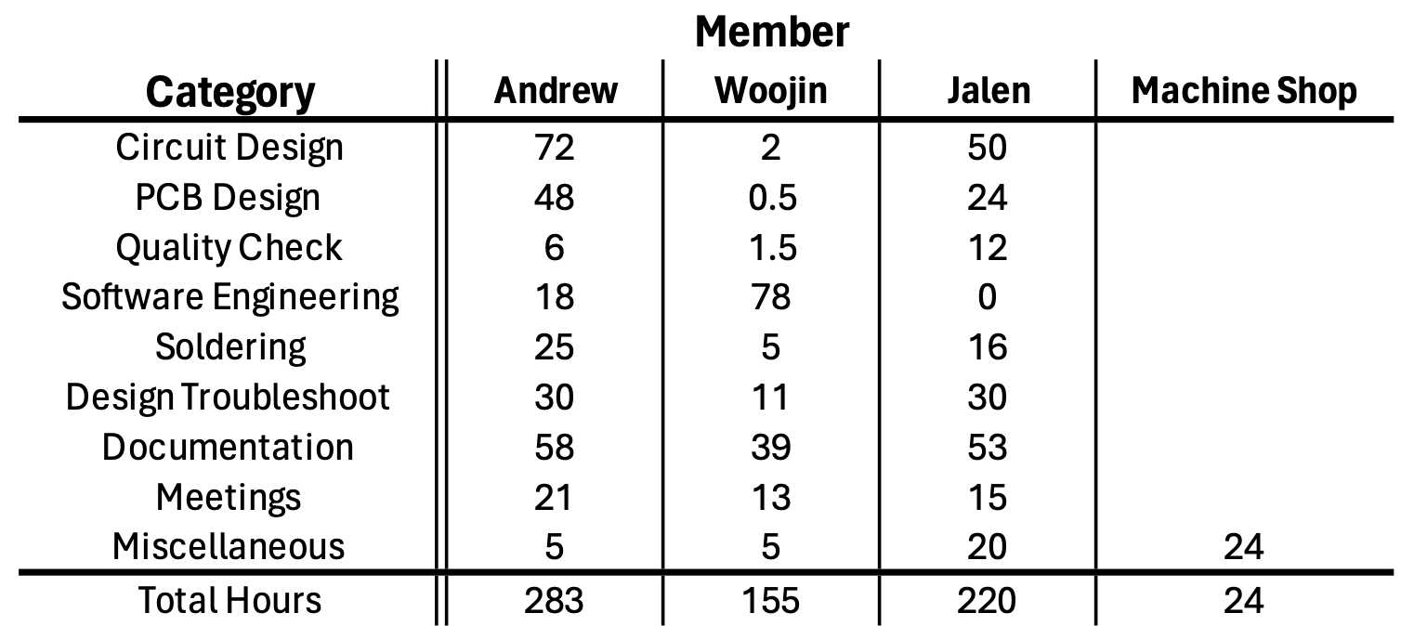

###### Table 1 – Estimated Development Hours [46]

With mixed electrical engineers and computer engineers in our group, we all have different hourly wages. Using the average UIUC ECE computer engineering published salary in 2021-2022 ($109,176.00), using 2080 work hours in a work year, we can expect an average hourly salary of $52.49.

$\frac{109,176.00}{2080 hours}=52.49 per hour$ (1)

Summing up the total labor hours in *table 1* above and multiplying it by the average salary *(1*), we obtain the total cost for labor to be: $34,538.42 for this project.

Aside from our own hours of labor, the machine shop performed 24 hours of work to modify our humidifier with some parts included in *Table 1 – Estimated Development Hours .*The machine-shop technician’s hourly cost is not public, so we will not include the cost in the total cost of development above.

## 3.3 Approximate Total Cost

###### Table 2 – Total Cost [47]

In total, the humidifier project cost $35,219.37, as seen in *Table 2 – Total Cost* . Most of the cost is from 16 weeks (about 3 and a half months) of labor, as broken down in *section 3.2* above.

# 4 Conclusion

## 4.1 Accomplishments and Uncertainties

Our project was very successful. We have completed all the high-level requirements that we set out to do. The sensor subsystem was able to successfully receive humidity and temperature data from the SHT45 sensor and relay the data to the humidifier subsystem via 2.4GHz Wi-Fi. Taking the humidity and temperature data, the humidifier subsystem was able put the data through an algorithm to determine the operation of the humidifier fan. Similarly, taking the data from the two water level sensors, the humidifier subsystem was able to determine the operation of the water valve. As a bonus, a webpage was created to view the humidity and temperature data live. On top of that, manual controls were created to operate the humidifier and water valve directly by the user. There were no uncertainties in our project, as all the parts were fully functional. We were able to run the humidifier for 4-weeks non-stop. The humidifier system never had a problem in the 4 weeks and proves the success of our project. However, there are always ways we can improve our product.

## 4.2 Future Work

In the future, we hope to link our humidifier with Amazon Alexa, Apple HomeKit, and Google Assistant. This way, the humidifier can be manually controlled, even when the user is not connected to the access point. The UI of the webpage can be improved also. We will use buck converters instead of linear voltage regulators to power our PCB. This will allow us to only use the 12V input in our humidifier subsystem. Furthermore, we can reduce the size of the PCB by preprogramming the ESP32, then soldering the programmed ESP32 onto the PCB. Aside from that, creating our own switching regulated supply would help save even more costs in the final product.

Our product is very modular. Any humidifier on the market can utilize it. With our abundant testing, we are confident that our product is almost ready for the market. Without the water level sensing system and the water valve, anyone currently having a humidifier, or is buying a manual humidifier can use our auto on-off system. To have a humidifier with an auto-refilling system as we proposed, we will need more funding for further research and development to build a new humidifier ground up. These are the goals we have for the future, though we are not able to provide our whole project for the market currently, we are happy that we are able to provide an alternative product that reaches even more people to help fund our dream product of a fully automatic humidifier.

# 5 Appendix

## 5.1 Appendix A – RV Table Verifications

###### Figure - A-1 [32]

###### Figure - A-2 [33]

###### Figure - A-3 [34]

###### Figure - A-4 [35]

###### Figure - A-5 [36]

###### Figure - A-6 [37]

###### Figure - A-7 [38]

###### Figure - A-8 [39]

###### Figure - A-9 [40]

###### Figure - A-10 [41]

###### Figure - A-11 [42]

###### Figure - A-12 [43]

## 5.2 Appendix B – Schematics

5.2.1 Appendix B.1 - Humidifier Subsystem

###### Figure - B-1 [11]

###### Figure - B-2 [11]Figure - B-3 [10][11]

###### Figure - B-4 [11]

###### Figure - B-5 [11]

###### Figure - B-6 [10][11]

###### Figure - B-7 [10][11]

###### Figure - B-8 [10][11]

###### Figure - B-9 [10][11]

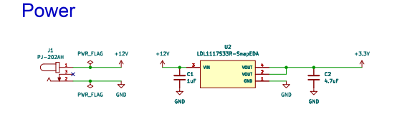5.2.2 Appendix B.2 - Humidity Sensor Subsystem

###### A diagram of a circuit board Description automatically generatedFigure - B-10 [10]

*Figure - B-11 [10]*

## 5.3 Appendix C – Required Parts and Cost

###### Figure C-1 - Sensor Subsystem Parts [44]

###### Figure C-2 - Humidifier Subsystem Parts [45]

## 5.4 Appendix D – Ethics and Safety

For our initial examination of ethics, we were able to justify our project using the IEEE code of ethics [6][13]. As students and soon-to-be workers, we know that whatever we do will have an impact on the world, primarily through the products and services we work on. Therefore, we must make sure to set some ethical guidelines that match with the code.

 5.4.1 Ethics

1. To uphold the highest standards of integrity, responsible behavior, and ethical conduct in professional activities. [6]

a. We will keep an open-minded state to each other's opinions. Utilizing everyone’s opinions, we will try to find the most ideal solution to our problems.

b. We will keep the integrity of our research to the highest degree. All data collected will be the truthful original and will not be “tuned” in any way.

c. We will keep the safety of our members and those working around us to the utmost highest standard.

d. We will adhere to the rules and regulations of the University of Illinois and ECE445’s lab-conduct rules. [48]

e. Constructive advice and criticisms will be accepted, and any forms of bribery will not be tolerated.

1. To treat all persons fairly and with respect, to not engage in harassment or discrimination, and to avoid injuring others. [6]

a. We will treat all members within and outside our group with respect on physical and non-physical standpoints.

b. Sexual harassment is not tolerated and will be reported to appropriate parties.

1. To strive to ensure this code is upheld by colleagues and co-workers.[6]

a. We will strive to uphold this code of conduct provided from IEEE and in our team contract. Any behavior outside the rules will be reported to the correct authorities.

1. To seek, accept, and offer honest criticism of technical work, to acknowledge and correct errors, to be honest and realistic in stating claims or estimates based on available data …[6]

a.    A central ethical concern includes directly impacting humans as a first resort without being able to test otherwise. For example, for most scientific products, humans are the final stage of a trial in a product because all previous stages have been cleared or given approval through uses of inanimate objects or lab animals. Our problem is generally a comfort-based one, and so the general ethical concern would be the first stage exposure to humans since there would not be a test trial. If our main issue is comfort, we will never know how it feels until actual humans have tested it. Therefore, as one of the IEEE Code of Ethics indicates [6], we will seek and accept any technical criticisms from TA, instructors, and machine shop, be realistic and responsible to revise the problem until we reach agreement. On top of that we will measure the humidity carefully and regulate with the correct amounts of moisture, making sure that we only deviate from the average quantity only once we have received indication that it is comfortable.

In this section, we consider every type of the most common situations that could occur when using our automatic humidifier product.

* 1. A safety concern would be the wall plug power. This is 120 V AC power typically, and so to prevent electrocution and shock issues, we would need to be aware of our surroundings and to connect the plug into the wall without any external connections to the outlet interrupting it in any way, such as holding loose wires or the metal section of the plug when you are plugging it into the wall.
  2. A safety concern is the issue of potential bacteria and mold. Our automatic humidifier should get rid of this, but this issue could severely impact the humidifier if there turns out to be traces of something contagious that can be widespread with the device. The dangers of something airborne that could get into your lungs would be catastrophic if not regulated correctly.
  3. Another possible safety issue could be the moving parts of a fan that could injure you if you try to touch the mechanical components. The fan’s motor will likely be insulated from external touch, but there is always a chance that something breaks and another chance that the moving part accidentally comes in contact with someone’s finger or something easily mistouched, leading to a higher chance of injury.
  4. A common matter that arises as well is if there is a connected cable that meets water. Our humidifier will likely be powered through a wired connection, and any water that comes into contact either from the humidifier or an external water source will damage the system, or even worse, cause physical harm to someone. This safety issue would need to be fixed through epoxy or some type of non-porous material insulating the device and its connections.

1. Dangerous chemicals are a final hazard that could be caused intentionally or by accident. Chemicals could be an issue if put inside the supply which normally contains water. If a dangerous fluid was put in the supply on purpose, then the humidifier might act as normal, sensing the humidity levels and then dispersing a life-threatening liquid instead of water. This would cause great harm and even possibly death if misused, so it is of utmost importance that the person using the device is careful and is sensible. Otherwise, the designers are not subject to responsibility and take no claim in the misuse of the product, which in that case, the user should refer to the instructions provided.

## 5.5 Appendix E - References

1. F. Hecht, “Wifi Propagation,” *freedom*, 2017. https://doc.freefem.org/tutorials/wifiPropagation.html (accessed Mar. 29, 2024).
2. M. Marwell, “Issues with the I2C (Inter-IC) Bus and How to Solve Them,” *DigiKey*, Aug. 09, 2018. Accessed: Mar. 29, 2024. [Online]. Available: https://www.digikey.com/en/articles/issues-with-the-i2c-bus-and-how-to-solve-them
3. MetaGeek, “Wi-Fi and Non Wi-Fi Interference,” *MetaGeek*, 2024. https://www.metageek.com/training/resources/wifi-and-non-wifi-interference/ (accessed Mar. 29, 2024).
4. A. V. Arundel, E. M. Sterling, J. H. Biggin, and T. D. Sterling, “Indirect health effects of relative humidity in indoor environments.,” *Environmental Health Perspectives*, vol. 65, no. 65, pp. 351–361, Mar. 1986, doi: 10.1289/ehp.8665351.
5. V. Perrone *et al.*, “The Epidemiology, Treatment Patterns and Economic Burden of Different Phenotypes of Multiple Sclerosis in Italy: Relapsing-Remitting Multiple Sclerosis and Secondary Progressive Multiple Sclerosis,” *Clinical Epidemiology*, vol. Volume 14, no. 14, pp. 1327–1337, Nov. 2022, doi: 10.2147/clep.s376005.
6. IEEE, “IEEE Code of Ethics,” *IEEE Code of Ethics*, 2020. https://www.ieee.org/about/corporate/governance/p7-8.html (accessed Mar. 29, 2024).
7. University of Illinois, “Salary Averages,” *UIUC*, 2022. https://ece.illinois.edu/admissions/why-ece/salary-averages (accessed Mar. 29, 2024).
8. Environmental Protection Agency, “Care for your air: A guide to indoor air quality,” *US EPA*, Aug. 07, 2023. https://www.epa.gov/indoor-air-quality-iaq/care-your-air-guide-indoor-air-quality (accessed Mar. 25, 2024).
9. Sensirion, “Datasheet -SHT4x,” *Sensirion*, Aug. 2023. https://sensirion.com/media/documents/33FD6951/6555C40E/Sensirion_Datasheet_SHT4x.pdf
10. A. Sherwin, *ECE445 Team 11 - Sensor Subsystem Schematic*. 2024.
11. A. Sherwin, *ECE445 Team 11 - Humidifier Subsystem Schematic*. 2024.
12. Espressif, “ESP32-S3-WROOM-1 ESP32-S3-WROOM-1U Datasheet,” *Espressif*, 2023. https://www.espressif.com/sites/default/files/documentation/esp32-s3-wroom-1_wroom-1u_datasheet_en.pdf
13. IEEE, “IEEE Code of Ethics,” *IEEE Code of Ethics*, Jun. 2020. https://www.ieee.org/about/corporate/governance/p7-8.html (accessed Mar. 26, 2024).
14. Espressif, “sch_esp32-s3-devkitc-1_v1_20210,” *Espressif*, Apr. 13, 2022. https://dl.espressif.com/dl/schematics/SCH_ESP32-S3-DevKitC-1_V1.1_20220413.pdf (accessed Mar. 26, 2024).
15. A. Sherwin, *Sensor Subsystem Block Diagram (Close-Up)*. 2024.
16. A. Sherwin, Humidity Subsystem Block Diagram (Close-Up). 2024.
17. D. Workshop, “ESP NOW - Peer to Peer ESP32 Communications,” DroneBot Workshop, Apr. 03, 2022. https://dronebotworkshop.com/esp-now/
18. K. Rembor, “Adafruit Sensirion SHT40, SHT41 & SHT45 Temperature & Humidity Sensors,” Adafruit Learning System, Feb. 04, 2021. https://learn.adafruit.com/adafruit-sht40-temperature-humidity-sensor/arduino
19. cplusplus, “std::chrono::high_resolution_clock::now,” cplusplus. https://cplusplus.com/reference/chrono/high_resolution_clock/now/ (accessed Apr. 20, 2024).
20. cplusplus, “std::chrono::nanoseconds,” cplusplus. https://cplusplus.com/reference/chrono/nanoseconds/ (accessed Apr. 20, 2024).
21. me-no-dev, “ESPAsyncWebServer/README.md at master · me-no-dev/ESPAsyncWebServer,” GitHub. https://github.com/me-no-dev/ESPAsyncWebServer/blob/master/README.md
22. Tea, “ESP32 Web Server periodic updating problem,” Stack Overflow. https://stackoverflow.com/questions/64610221/esp32-web-server-periodic-updating-problem
23. antepher, “ESP32 Arduino: HTTP server over soft AP,” techtutorialsx, Jan. 07, 2018. https://techtutorialsx.com/2018/01/07/esp32-arduino-http-server-over-soft-ap/
24. ESPRESSIF, “ESP-NOW - ESP32 - — ESP-IDF Programming Guide v5.2.1 documentation,” espressif.com. https://docs.espressif.com/projects/esp-idf/en/stable/esp32/api-reference/network/esp_now.html
25. Center for Drug Evaluation and Research, “Use Caution When Giving Cough and Cold Products to Kids,” *U.S. Food and Drug Administration*, 2018. <https://www.fda.gov/drugs/special-features/use-caution-when-giving-cough-and-cold-products-kids> (accessed May 01, 2024).
26. A. Sherwin, Consumer Visual Aid. 2024.
27. A. Sherwin, Component Visual Aid. 2024.
28. A. Sherwin, Overall Block Diagram. 2024.
29. A. Sherwin, Humidity Subsystem PCB. 2024.
30. A. Sherwin, Webserver Webpage. 2024.
31. A. Sherwin, Sensor Subsystem PCB. 2024.
32. A. Sherwin, RV Table A-1. 2024.
33. A. Sherwin, RV Table A-2. 2024.
34. A. Sherwin, RV Table A-3. 2024.
35. A. Sherwin, RV Table A-4. 2024.
36. A. Sherwin, RV Table A-5. 2024.
37. A. Sherwin, RV Table A-6. 2024.
38. A. Sherwin, RV Table A-7. 2024.
39. A. Sherwin, RV Table A-8. 2024.
40. A. Sherwin, RV Table A-9. 2024.
41. A. Sherwin, RV Table A-10. 2024.
42. A. Sherwin, RV Table A-11. 2024.
43. A. Sherwin, RV Table A-12. 2024.
44. A. Sherwin, Sensor Subsystem Parts. 2024.
45. A. Sherwin, Humidifier Subsystem Parts. 2024.
46. A. Sherwin, Estimated Development Hours. 2024.
47. A. Sherwin, Total Cost. 2024.
48. Engineering IT Shared Services, “Lab :: ECE 445,” *Senior Design Laboratory*, 2020. https://courses.engr.illinois.edu/ece445/lab/index.asp (accessed May 01, 2024).